Differentiation at Oakleigh State School
High Ability Learners
At Oakleigh State School our approach to differentiation for diverse learners is guided by the QLD Education Department’s P-12 CARF – (Curriculum, Assessment and Reporting Framework). It is through this advice that we have developed our whole school approach. Included in this is, how we identify and target teaching for high ability leaners.
In essence, the classroom teacher is responsible for differentiating for their students at the whole class level. The Australian Curriculum is multifaceted and it is through it, that all students can be catered for within their year level. Elements such as the General capabilities and Cross Curriculum Priorities can be used to enrich student learning and includes such components as critical and creative thinking, personal and social capability, literacy and numeracy, digital literacy, Ethical understanding and intercultural understanding. Aboriginal and Torres Strait Islander History and culture, and sustainability are the Cross Curriculum Priorities which add depth to the context of student learning.
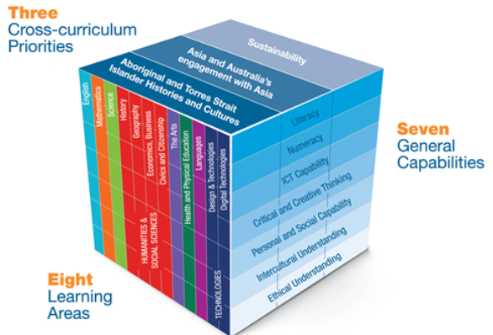
The Oakleigh SS differentiation model below shows how, through data collection and analysis some students may need targeted or intensive teaching whether they be below or well above year level standard.

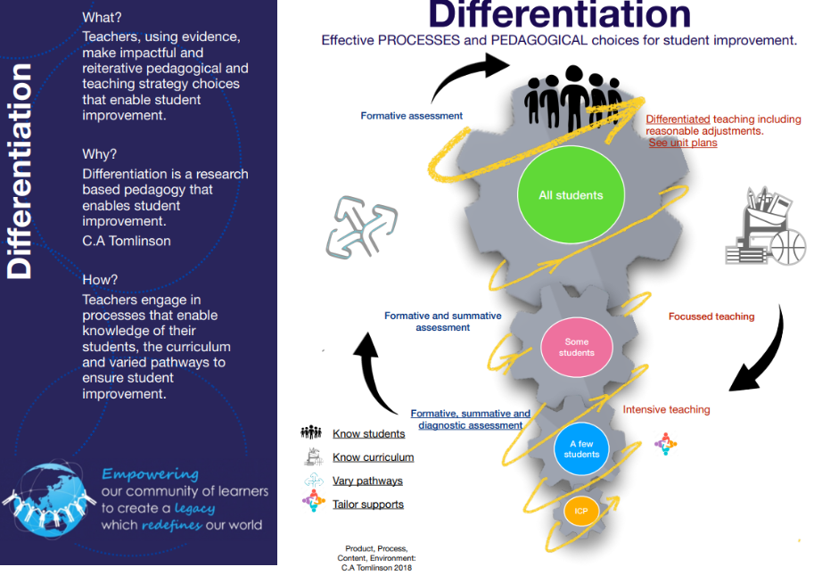
Part of Oakleigh’s approach to differentiation is to identify students who exhibit knowledge, skills and aptitudes well above year level standard and at times throughout the year, offer them extracurricular opportunities to enhance their learning experience.
Over the last two years we have engaged a High Ability Learner Coach who has organised a variety of programs, (which can change from year to year) for both identified high ability learners and otherwise, to engage in.
The following programs have been offered this year:
- Premier’s reading challenge – Available to all students.
- Chess Club – Available to all students.
- Reader’s Cup – Year 5-6 identified students
- Optiminds –Available to Years 2-6 students.
- BEBRAS Computational Challenge – All years 4-6 in class.
- Bardon Young Writers Program – Year 6 identified students
- Curriculum Leaders Maths competition – Year 6 identified students
- ICAS assessments – Optional involvement and available to Year 1-6 students.
- Curiosity STEM Art Project – Year 5-6 identified students.
- Year 4 Math investigations – Available to Year 2 & 4 Identified students.
- Ravensbourne Project - Creative Writing and Drama – Available to Year 4-6 identified students.
- Campbell’s Curiosity Shop – creative writing and Drama – Available to Year 1-3 identified students.
As part of our identification process, we use a variety of data sets, including A-E, Pat Reading and Math Diagnostic assessments, NAPLAN and SAGES (Screening assessment for gifted elementary and middle school students) data, along with class teacher anecdotal information and parent/carer information. We also use this information to guide our decision-making process as to who is eligible to participate in the extracurricular programs.

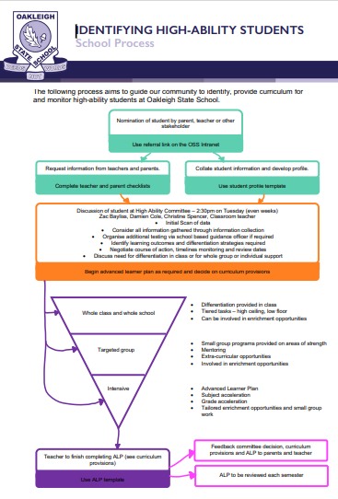

Each year the HALT – High Ability Learner Team review our processes and policy to ensure we are meeting the requirements of the P-12 CARF and ultimately, working towards catering for, both in the classroom and beyond, the exceptional learners we have.

